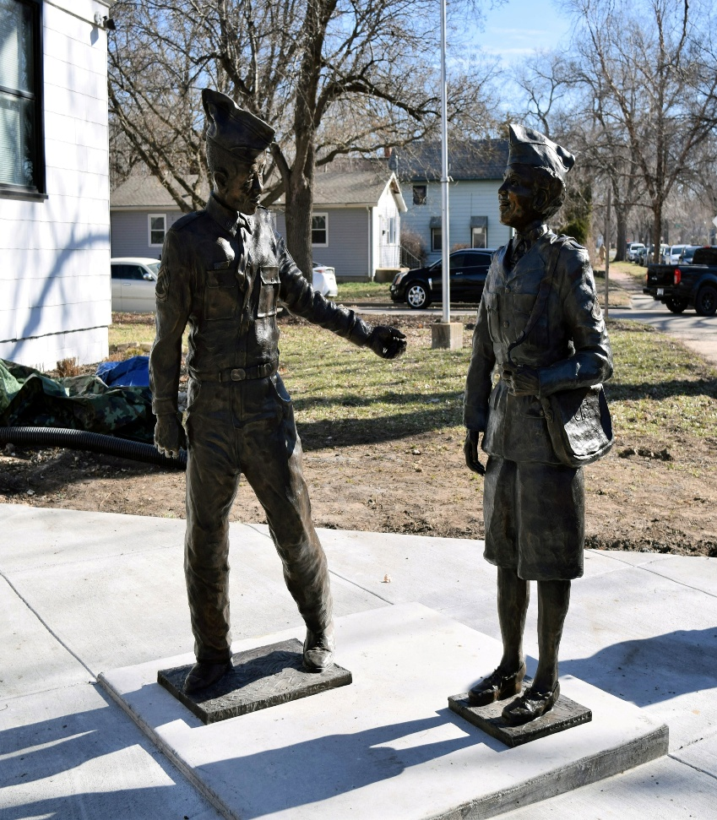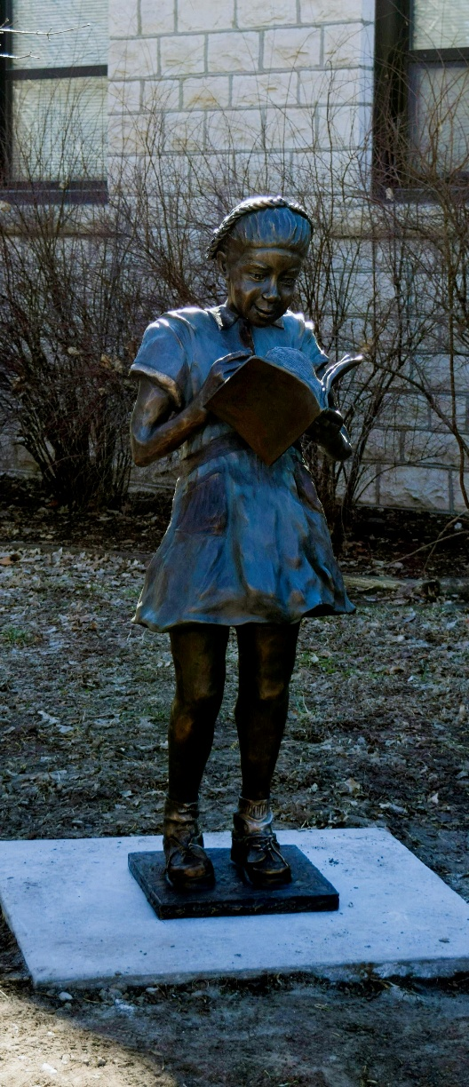
Public art plays a vital role in shaping community identity and creating a strong sense of place—key factors that influence where people choose to live and invest their lives.
Public art connects people, sparks conversation, and enhances the visual and emotional landscape of our city.

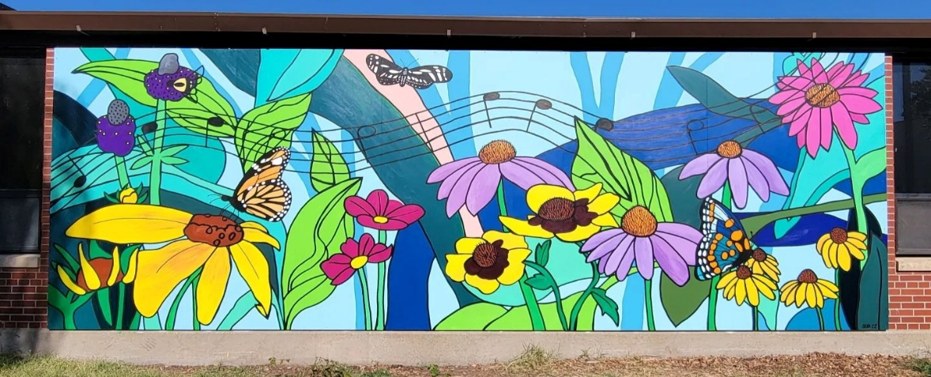
Murals, sculptures, or integrated functional design become landmarks of pride for residents and points of interest for visitors.
